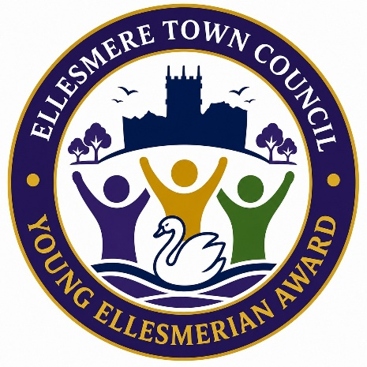
ELLESMERE TOWN COUNCIL
Tel: 01691 622689
Email: jo.butterworth@ellesmere-tc.gov.uk
Miss Joanne Butterworth
Town Clerk & RFO
1-3 Willow Street
Ellesmere
Shropshire
SY12 0AL

NOMINATION FORM
The purpose of the award is to encourage and recognise any behaviour or achievement that benefits the Ellesmere community. Nominations are open to everyone in the community. Eligible nominees must be aged 18 or under, either in the year of the award or at the time their achievement took place.
This form will be submitted to the Councillors to assist in their decision making and the award will take place during the Annual Meeting of Electors each year.
SECTION 1: NOMINEE DETAILS
Name:
Age:
Address:
Contact Details for Parent or Guardian of Nominee:
Telephone:
Email:
Nominees under the age of 18 when this form is completed or who are 18 years of age but not legally eligible to give consent, must get a parent/guardian signature to give permission for (a) and (b) below. If the Nominee is 18 years of age, and legally eligible to give consent, when this form is completed, they are giving permission themselves:-
(a) for the named Nominee to take part and be identified in the award.
(b) for the information on this form to be used throughout the awards process
Name of Individual Providing Permission:
Relationship to Nominee:
Signature:
SECTION 2: PROPOSER DETAILS
Name:
Address:
Contact Details for Proposer:
Telephone:
Email:
Relationship to Nominee:
Supporting Information: | Please explain in the following section, and continue on an additional page if necessary, why you have made this nomination and how the young person nominated has demonstrated one or more of the following criteria:-  - exceptional commitment to their community, school, families, or peers  - overcome significant personal challenges  - shown exceptional act(s) of kindness  - had a positive impact on other individuals  Please give specific examples and evidence of the nominee’s achievements where possible.

SECTION 3: SUPPORTING INFORMATION
Supporting information continued: -

Signature of Proposer:

Date:

Privacy Notice – Ellesmere Young Ellesmerian Award

The terms ‘you’ and ‘your’ also refer to the entrant or nominee where the entrant or nominee is under 18 years of age, or is aged 18 or over but is not legally able to provide consent.
Ellesmere Town Council is committed to being transparent about the personal information we collect and how it is used. We will only use your personal information in ways you would reasonably expect in connection with the Young Ellesmerian Award, and we will take all reasonable steps to protect your privacy. The Ellesmere Town Council Privacy Policy is available on our website, https://www.ellesmere-tc.gov.uk/wp-content/uploads/2023/07/Privacy-Policy-July-23.pdf, and explains how we collect, process and share personal information. We collect your personal information (and, where applicable, that of the entrant or nominee if they are a minor or not legally able to provide consent) solely for the administration and delivery of the Award. It will not be used for any other purpose. Your name and image may also be used for publicity purposes. Where the nominee is a minor, or is not legally able to provide consent, only the parent or guardian will be contacted.
Personal information will be retained for three months following the date of the Award. After this period, it will be securely destroyed, either by shredding, incineration or deletion from electronic devices. This retention period is necessary to allow any disputes to be resolved before the information is destroyed. By signing the front of this form, you confirm that you have read and understood this Privacy Notice and agree to the use of personal information relating to yourself or, where applicable, on behalf of a child or an adult who is not legally able to provide their own consent.

